Republic of the Philippines

**TECHNOLOGICAL UNIVERSITY OF THE PHILIPPINES**

College of Industrial Education

Ayala Boulevard cor. San Marcelino St. Ermita, Manila 1000

Telefax (02) 523-2293, Tel Nos. (632) 521 – 4063, Website: <http://www.tup.edu.ph>

SEM 3 Seminar in Professional Education

Activity No. 5

**Educational Technology**

**Learning Outcomes:**

1. Employ teaching strategies, methods, instructional materials and technology, classroom management techniques appropriate to subject areas and inclusive of learners from indigenous groups.
2. Demonstrate skills in developing and using a variety of conventional and non -conventional resources including Information and Communication Technology to address learning goals and needs of various learners.

**General Instructions**: Answer the following questions.

1. Discuss the following concepts:
   1. Education

Education is both the act of teaching knowledge to others and the act of receiving knowledge from someone else. Education also refers to the knowledge received through schooling or instruction and to the institution of teaching as a whole. Education has a few other senses as a noun.

* 1. Technology

Technology is the application of scientific knowledge to the practical aims of human life or, as it is sometimes phrased, to the change and manipulation of the human environment.

* 1. Educational Technology

Educational technology is the combined use of computer hardware, software, and educational theory and practice to facilitate learning.

1. Describe/Discuss the following Philosophical Framework behind Educational Technology
   1. Behaviorism

Behaviorism equates learning with changes in either the form or frequency of observable performance. Learning is accomplished when a proper response is demonstrated following the presentation of a specific environmental stimulus.

* 1. Cognitivism

Cognitive theories emphasize making knowledge meaningful and helping learners organize and relate new information to existing knowledge in memory. Instruction must be based on a student's existing mental structures, or schema, to be effective.

* 1. Constructivism

Constructivism is the theory that says learners construct knowledge rather than just passively take in information. As people experience the world and reflect upon those experiences, they build their own representations and incorporate new information into their pre-existing knowledge (schemas).

1. Identify the purpose of Visual Devices

* Make a presentation more convincing
* Maintain the audience's interest in the presentation
* Assist the speaker in remembering the points to make during the presentation.
* Clarify the presentation's structure.
* Assist an audience in understanding and remembering information from a presentation.

1. What are the traditional forms of Visual Aids? Describe each.

* Whiteboards - Whiteboards are excellent for providing additional explanations, such as clarifying difficult vocabulary, explaining the order of a procedure, drawing diagrams, and so on. They are typically used for writing headings, crucial information to be displayed during the presentation, and noting student suggestions.
* Charts and graphs- A wide range of charts and graphs are available to help the students with several tasks, including pie charts, line graphs, bar charts, flow charts, and organizational charts.
* Handouts- The important material from the presentation or additional information for the presentation it may be printed on sheets of paper. These are known as handouts. They are typically utilized when issue is too hard to grasp simply by speaking.
* Flip chart- Flip charts are a low-cost way to record and convey information when presenting in classroom. They have relatively little technology. They are useful when you only have a small number of children. They are frequently used in brainstorming sessions to easily collect thoughts and summarize the material offered.

1. The following are different classification of Devices. Describe each and cite example.
   1. Extrinsic

Extrinsic semiconductors are **semiconductors that are doped with specific impurities**. The impurity modifies the electrical properties of the semiconductor and makes it more suitable for electronic devices such as diodes and transistors

* 1. Intrinsic

The standard ensures that an "intrinsically safe device" is **incapable of triggering combustion or igniting any gasses or fuels**. To put it simply, you can use it around gasses or fuels without risking static electricity or heat discharge from the device igniting the surrounding volatile gasses, powders and liquids

* 1. Material Devices

Materials for devices are materials employed in devices because of their particular properties, such as electrical, thermal, magnetic, mechanical, ferroelectric or piezoelectric properties.

* 1. Mental Devices

A word, phrase, object, or process used to help a person relax.

1. The following are the role of computer in the teaching and learning. Explain each.
   1. Computer as object of instruction

They allow students to progress at their own pace and work individually or problem solve in a group. Computers provide immediate feedback, letting students know whether their answer is correct. If the answer is not correct, the program shows students how to correctly answer the question.

* 1. Computer as tool for instruction

Computers have revolutionized the teaching profession in multiple ways. Teachers use computers to record grades, calculate averages, manage attendance and access data on student performance in online programs and assessments. Computers have also made it easier for teachers to vary their instructional delivery.

1. Explain the following:
   1. Distance Education
      * A learning delivery modality where learning takes place between the teacher and the learners who are geographically remote from each other during instruction.
      * Distance learning is a way of educating students online. Lectures and learning materials are sent over the internet. Students work from home, not in a classroom.
      * This helps the learners to set their study time for as long as they can concentrate. Along with flexibility, online education is also customized as per students' requirements and mastery levels.
   2. Massive Open Online Courses (MOOC)

* A a free web-based distance learning program that is designed for large numbers of geographically dispersed students.
* Massive Open Online Courses (MOOCs) are free online courses available for anyone to enroll. MOOCs provide an affordable and flexible way to learn new skills, advance your career and deliver quality educational experiences at scale.
* Millions of people around the world use MOOCs to learn for a variety of reasons, including career development, changing careers, college preparations, supplemental learning, lifelong learning, corporate eLearning & training, and more.

1. Differentiate synchronous distance learning from Asynchronous Distance Learning. Complete the matrix below.

|  |  |
| --- | --- |
| **Synchronous Distance Learning** | **Asynchronous Distance Learning** |
| * Synchronous means “at the same time.” It refers to a method of education delivery that happens in real-time. It requires live communication online. It uses technology, such as teleconferencing, to achieve this. * Synchronous learning allows students to engage with class materials at the same time as their peers as long as they can connect to the internet. | * Students receive clusters of weekly deadlines. They have the freedom to work at their own speed. Asynchronous distance learning comes with more opportunities for student interaction. * Students can access course content beyond the scheduled meeting or class time and interact through online conversations, quizzes, or video comments on their own schedule. |

1. Describe the following theories and principles in Educational Technology. Use illustration to better explain each theories or principles.
   1. **Dale’s Cone of Experience**

The Cone of Experience is a visual representation of the perception that learning activities may be classified into broad groups depending on how much they reflect non-abstract referents of real-life experiences. Many people see it as a dogmatic concept for choosing instructional methods. Dale's answers are imprecise enough to allow for a broad range of interpretations. Nonetheless, Cone has been examined in a variety of ways to give evidence to Dale's visual metaphor's vibrancy and appeal.

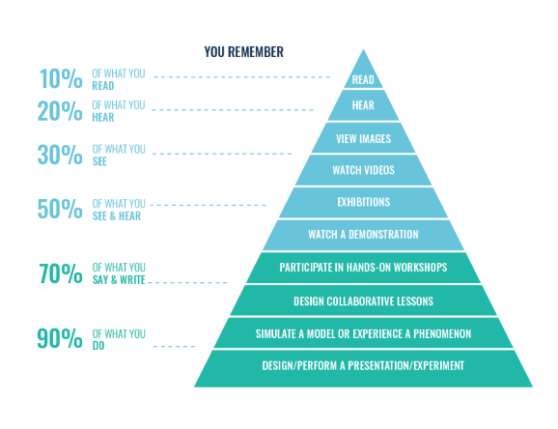

* 1. Three-Fold Analysis of Experience by Jerome Bruner

His research on children's cognitive development proposed three 'modes of representation': Enactive representation (based on action) Iconic representation (based on images) Symbolic representation (based on language).

Enactive (0-1 year), this mode entails encoding action-based information for storage in our memory - for example, a newborn recalling shaking a rattle by building a'muscular memory' of the job. This capacity to preserve a mental image 'in the mind's eye' is iconic (1 - 6 years). When studying a new subject, using images and diagrams to supplement verbal explanations may be beneficial. Symbolic (7 years and above), this more advanced phase is the final to emerge and is more adaptable than the previous two modes. Codes and symbols are used to store information, which is mostly done via the means of language. For example, the term "dog" refers to a certain kind of animal.

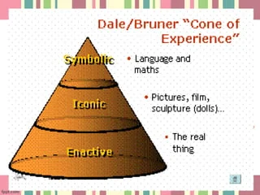

* 1. TPACK Framework

TPACK, a technology integration framework, requires teachers to combine technical, pedagogical, and content expertise to integrate edtech successfully (a.k.a. TPACK).

The TPACK framework recommends using certain technical instruments (hardware, software, apps, related information literacy practices, etc.) to teach and help students grasp the subject matter. TPACK mixes and recombines TK, PK, and CK. Technological pedagogical knowledge (TPK) describes relationships and interactions between technological tools and specific pedagogical practices, pedagogical content knowledge (PCK) between practices and learning objectives, and technological content knowledge (TCK) between technologies and learning objectives. TPACK addresses the links between all three sectors and recognizes that educators operate in this complicated context.

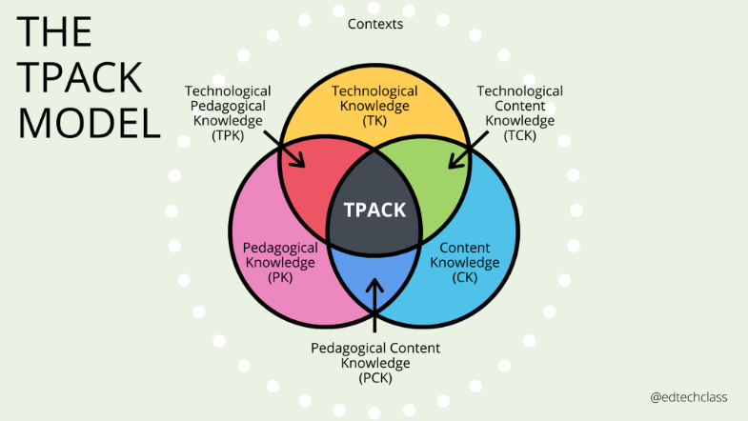

* 1. Gagne’s 9 Instructional Events

Gagne's Nine Events of Instruction, based on his 1960s research, are designed to offer teachers, trainers, instructors, and instructional designers with a set of recommendations for creating efficient and successful learning experiences. Gagne's technique presents a communication strategy that is meant to increase the human learning process at each phase. Learners are supposed to grow interested, engaged, and involved in the learning issue as each stage is accomplished.

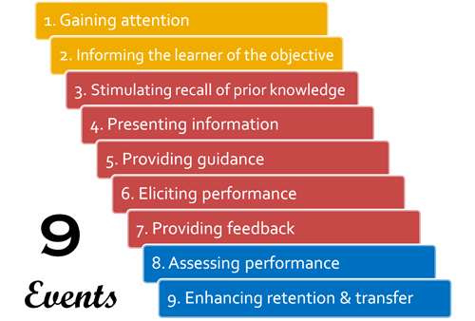

* 1. Merill’s Principle of Instruction

The problem-based teaching methodologies included within Merrill's First Principles of Instruction have a history of producing excellent results for students and teachers alike. The five techniques that make up the principles are based on the five core principles of education, and they are meant to guide the best practices that should be used while educating learners. The improvement of student learning, motivation, and engagement that results from the use of these tactics by instructors. It is vital to note that although while the principles are numbered, none of them are significant than the others, and it is imperative that all of them be put into practice simultaneously in order to achieve the desired results. These methods collaborate to provide a learning environment in the classroom that encourages students to demonstrate mastery of material and to be actively involved in their studies.

.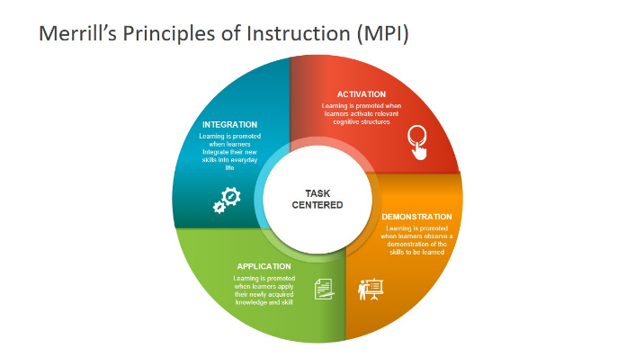

* 1. Levels of Technology Integration

The Technology Integration Matrix (TIM) is a framework that outlines the steps to be taken in order to describe and target the use of technology to improve educational outcomes. The TIM is designed to combine five interdependent qualities of meaningful learning settings. These characteristics are goal-directed, active, collaborative, and genuine learning. These aspects are linked to the five stages of technological integration, which are referred to as entry, adoption, adaptation, infusion, and transformation.

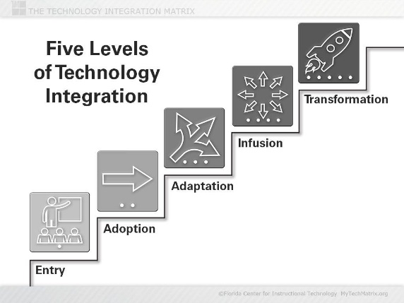

1. Illustrate and describe the following Instructional Design Model
   1. ADDIE Model

The ADDIE model is a technique used by instructional designers and training developers to plan and construct successful learning experiences. The ADDIE concept is broad enough to be utilized to construct any form of learning experience for any audience, from K-12 teaching courses on cellular biology to corporate training programs for an ERP software update. ADDIE is an acronym that stands for each aspect of developing an excellent eLearning course. ADDIE is an acronym that stands for Analysis, Design, Development, Implementation, and Evaluation. The model is designed to be completed in the sequence of Analysis through Evaluation. ADDIE, on the other hand, is intended to be a flexible, ongoing process of changes and revisions.

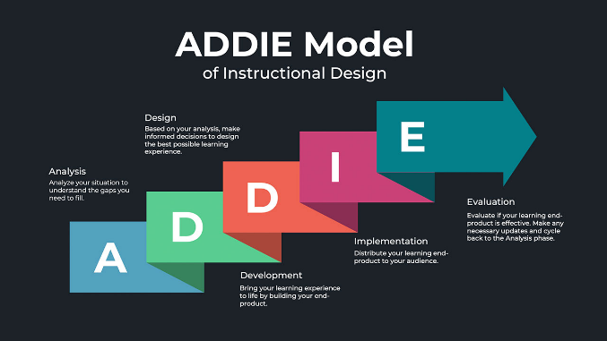

* 1. ASSURE Model

The ASSURE model is a step-by-step procedure for organizing and delivering instructions that incorporates technology and media into the educational process. It also refers to a methodical approach to lesson planning that assists instructors in structuring instructional operations. To become proficient in today's classroom, it is critical to understand when to use a variety of educational tactics and passive interactive technologies. According to Heinich and Smaldino (2002), efficient utilization of media technologies and a systematic framework for their usage are required. As a result, the ASSURE model guide, which highlights six important phases in the instructional planning process, was proposed.

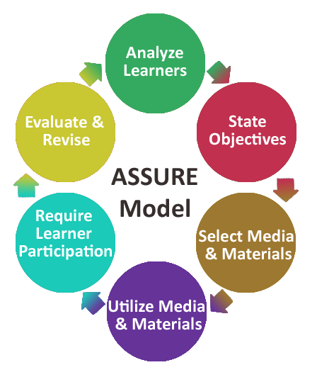

1. Differentiate the Two parts of Computer;
   1. Hardware

Any physical component of a computer is referred to as hardware. This includes components like keyboards, monitors, and the inside workings of gadgets like hard drives and microchips.

* 1. Software

Software, which includes computer programs and mobile apps, is anything that instructs hardware on what to do and how to do it.

1. Describe the four categories of hardware. Cite example for each category.
   1. Input Devices

are tools that are used to input data or commands to the central processor unit. are categorized according on the process they employ. Example: Keyboard, mouse

* 1. Output Devices

The output category includes hardware elements that disseminate and display information as well as data. The result of a cycle that begins with the entry of raw data and processing is output. These elements fall under the categories of output for both softcopy. Example: Monitor

* 1. Storage Devices

It was categorized as a memory/storage device. Under primary and secondary memory, storage is separated. Either they are volatile, or they aren't. Example: CPU, and RAM.

* 1. Processing Devices

Processing is the core function of a computer. It is the stage where raw data is transformed into information. Once data has been processed, it can be used for useful purposes. Example: Microprocessor.